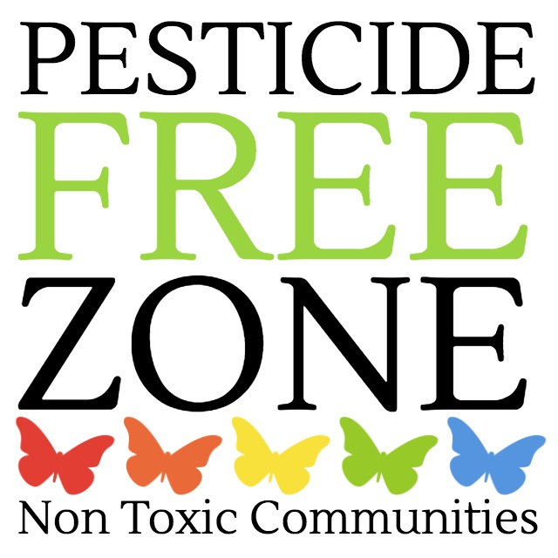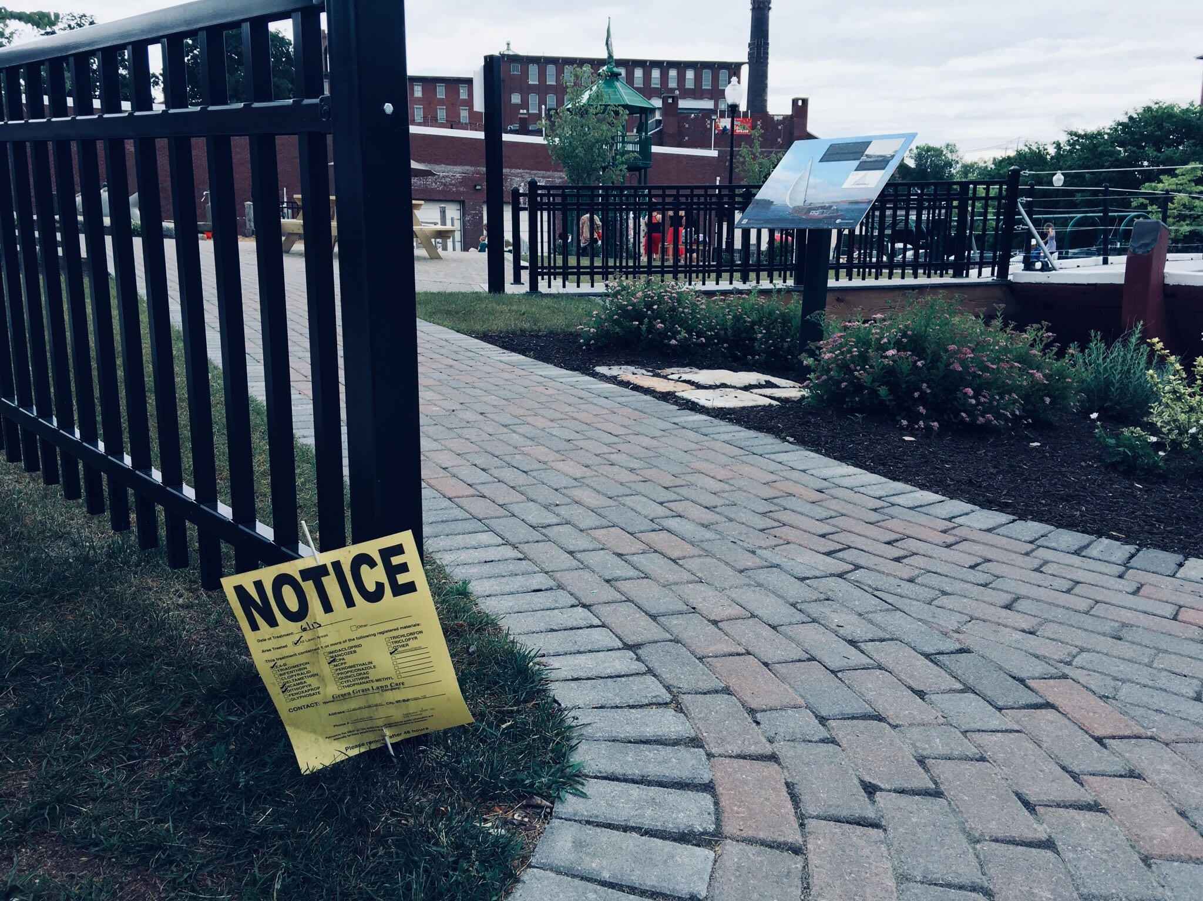

Keeping Kids Safe From Pesticides

Children encounter pesticides everyday and are uniquely vulnerable to their toxicity. Prenatal and early childhood exposure to pesticide is associated with *pediatric cancers, decreased cognitive function, and behavioral problems*. Americans use more than a billion pounds of pesticide each year on farm crops and lawns, in homes, schools, parks, hospitals and public spaces.

source: American Academy of Pediatrics, US Environmental Protection Agency

**How can we protect our children where they learn, live & play?**

Ask your city to adopt safer choices in turf care and pest management.

Ask the school to stop using toxic pesticides and choose effective alternatives.

Use pest management methods at home that do not rely on toxic pesticides.